Prerequisite:

1) [Ethereum Solidity](https://solidity.readthedocs.io/en/v0.4.23/)

2) [NodeJS](https://nodejs.org/en/download/)

3) [Solc JS plugin](https://www.npmjs.com/package/solc" \t "_blank)

4) [Web3 JS plugin](https://www.npmjs.com/package/web3)

5) [JQuery](https://jquery.com/" \t "_blank)

6) [Truffle 4 framework](http://truffleframework.com/docs/ganache/using)

7) [Ganache/ testrpc tool](http://truffleframework.com/docs/ganache/using)

8) [Github](https://github.com/muchouhan/bgc)

9) [Atom tool](https://atom.io/)

Steps:

1. Download code from [Github repository](https://github.com/muchouhan/bgc).
2. Open Ganache on 8545 ports.

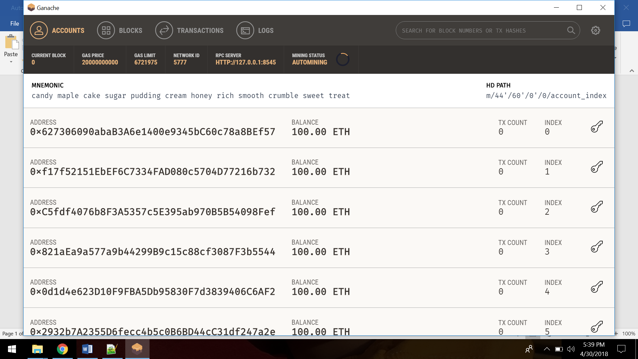

1. Navigate to folder

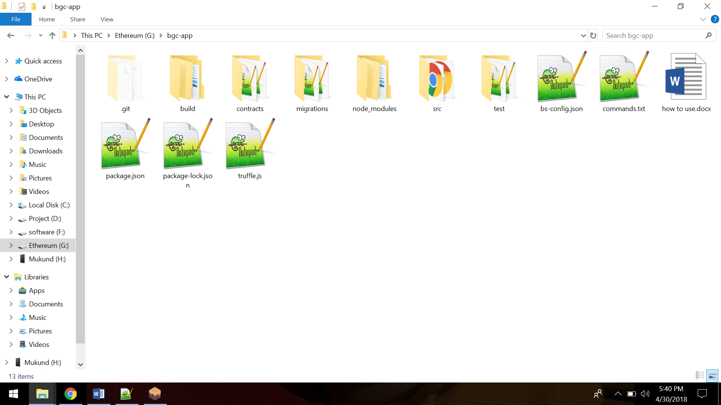

1. Open terminal window

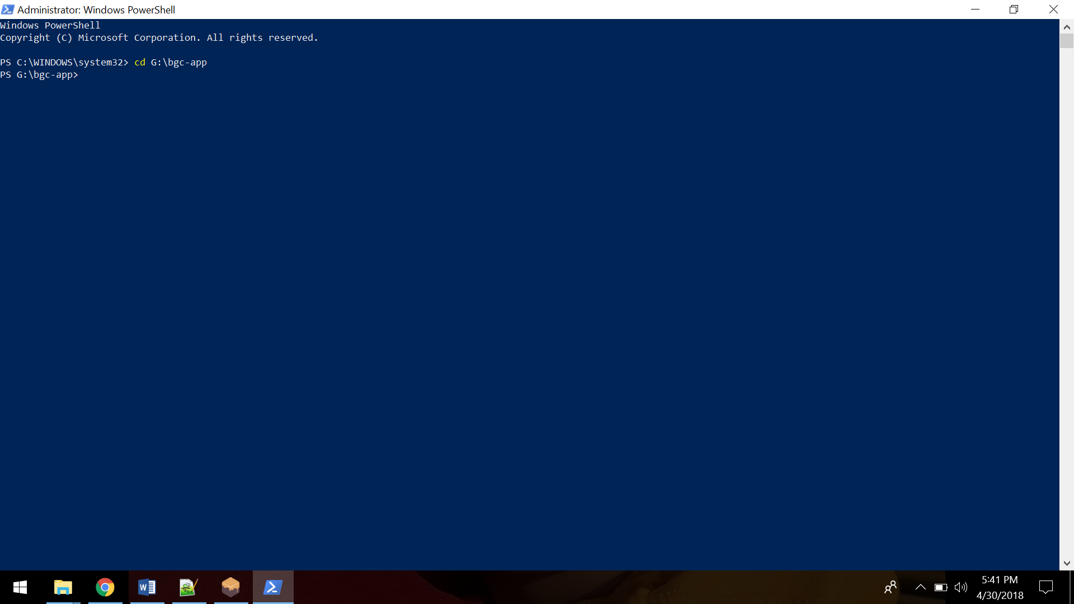

1. Compile code using truffle command

truffle migrate --compile-all --reset --network development

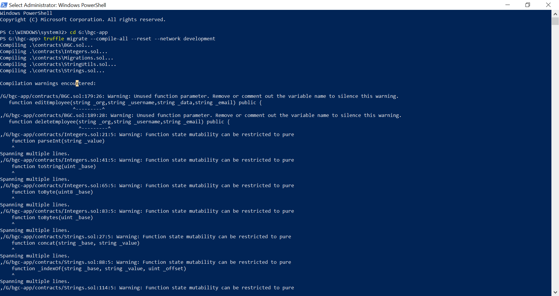

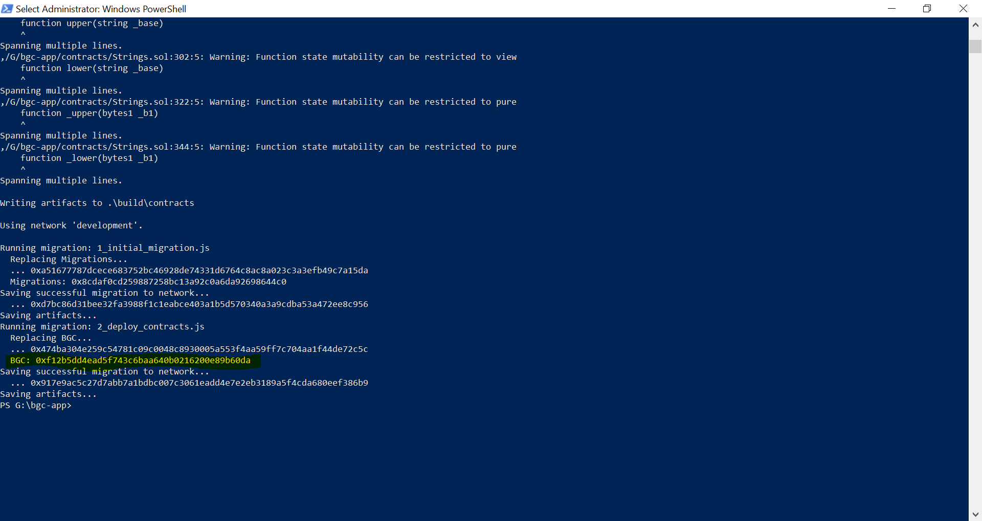

1. Copy BGC deployed contract address and insert in index.js file.

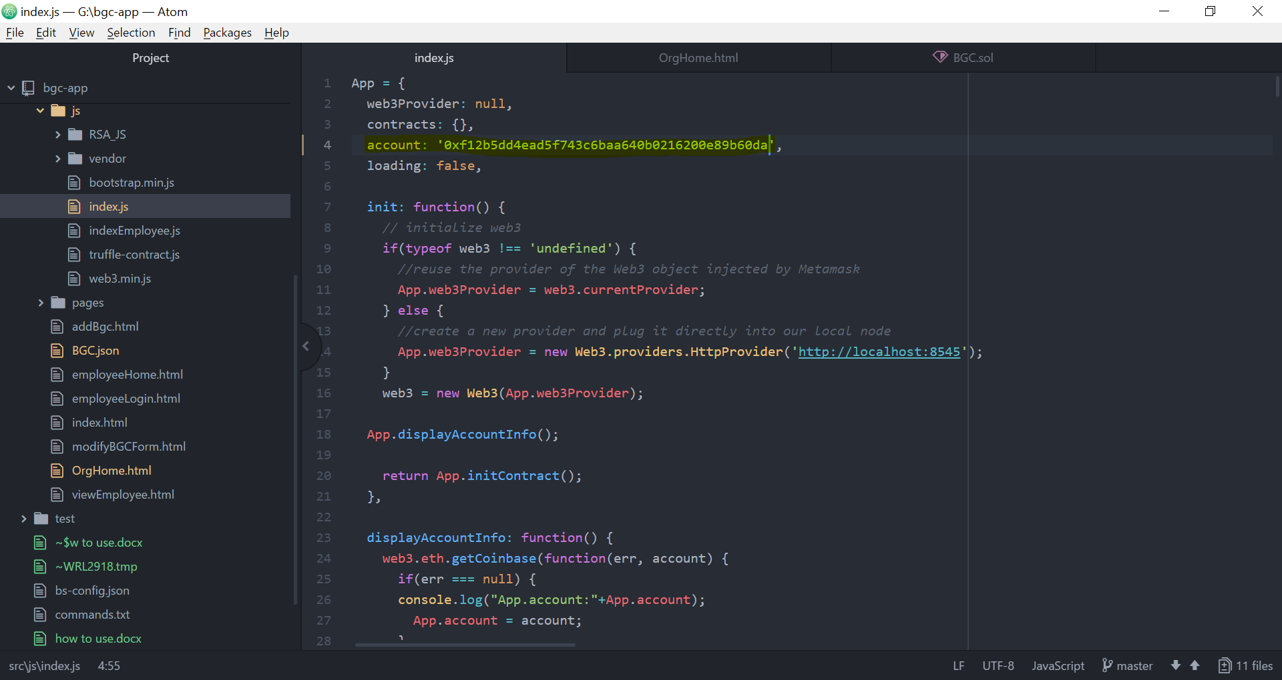

1. Copy generated BGC.json file “build/contracts”and paste it in “src” folder.

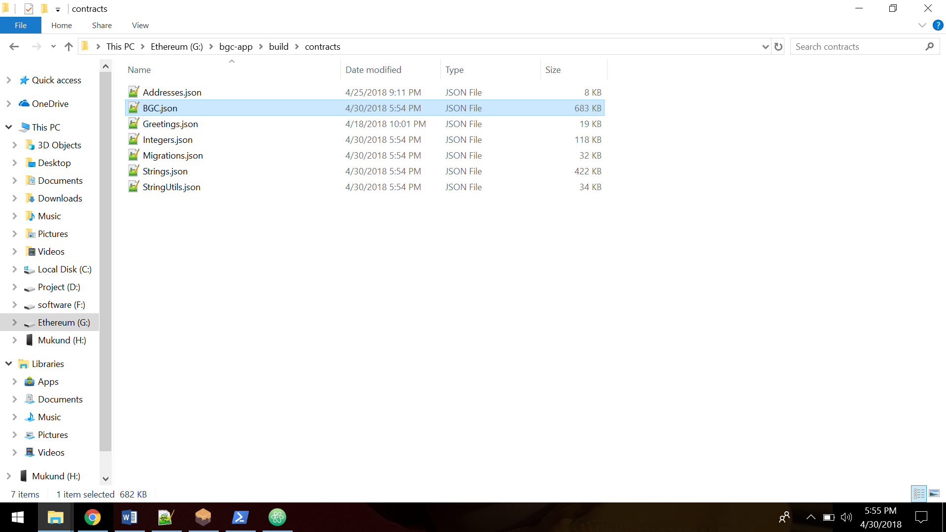

1. Run server using below command:

npm run dev

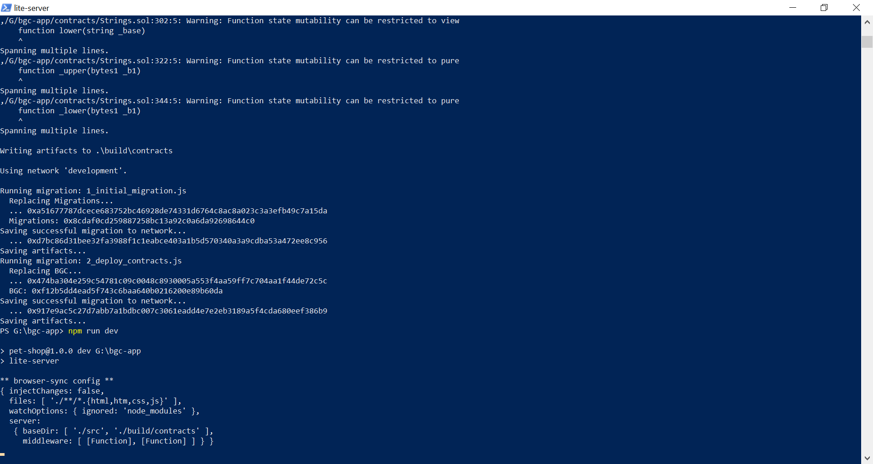



1. Click on sign up link.

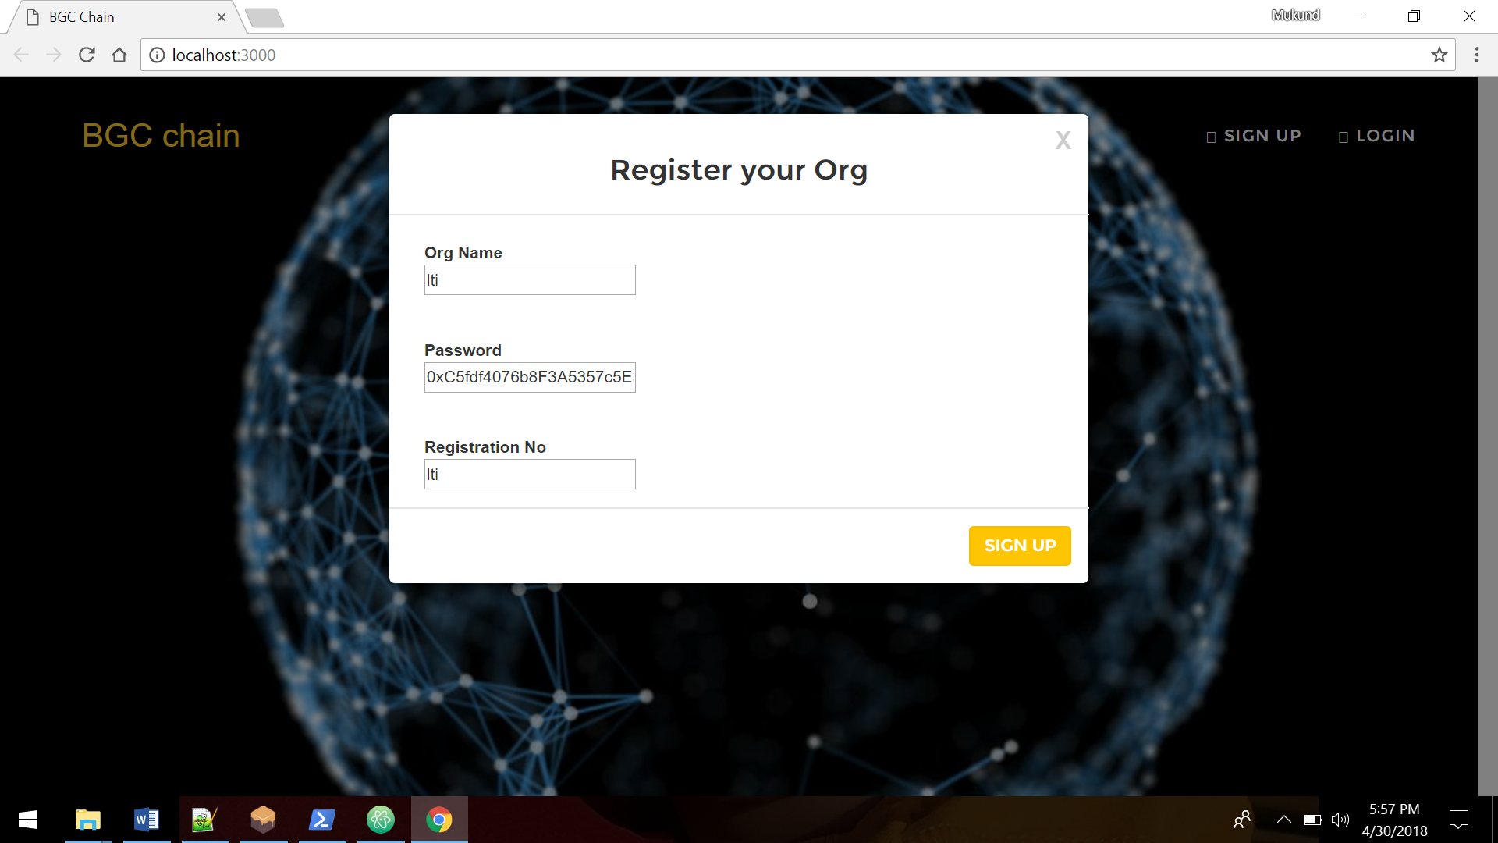

1. Provide Org name and take any generate account number as password and submit.

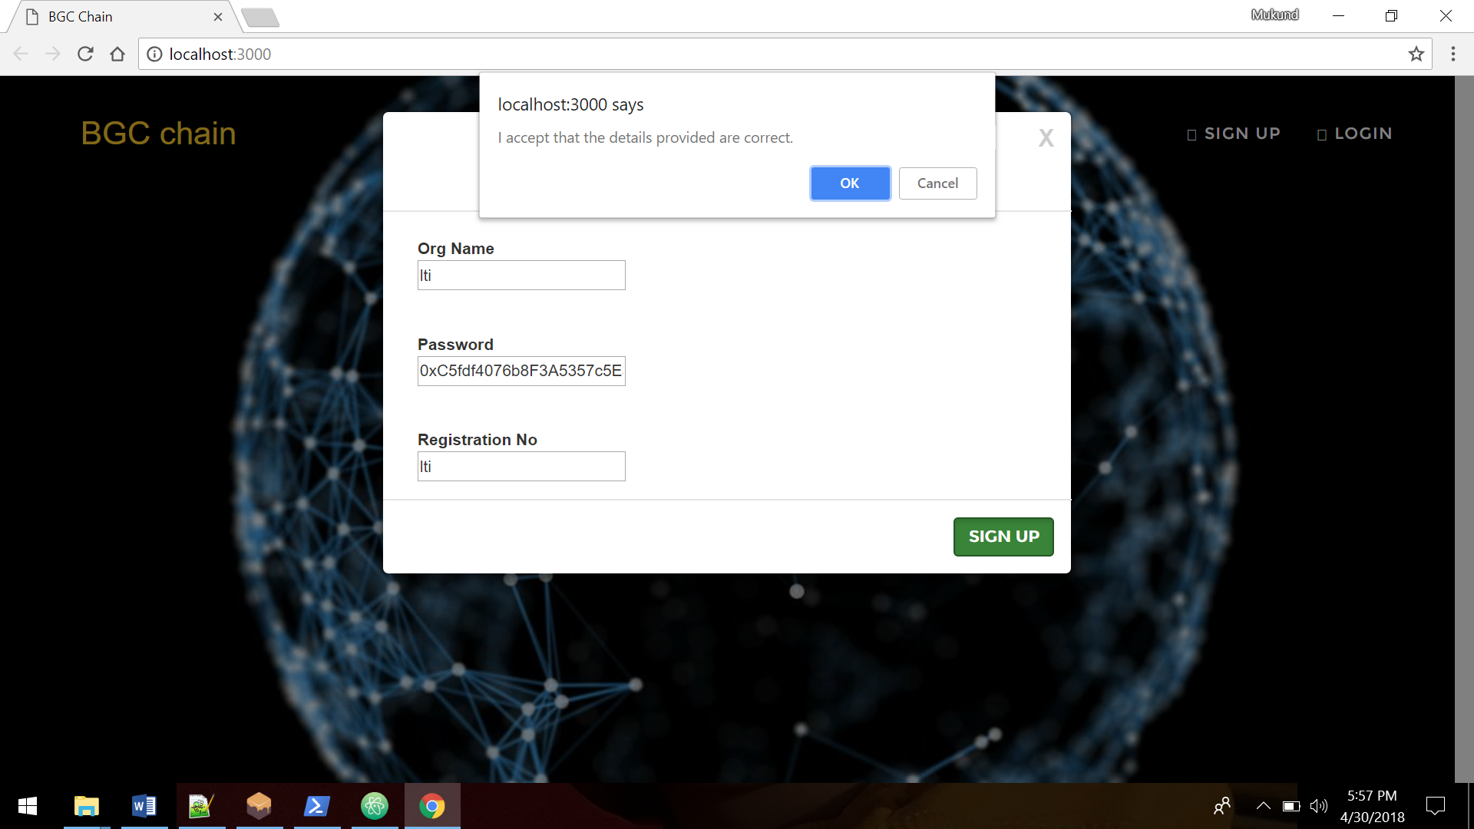

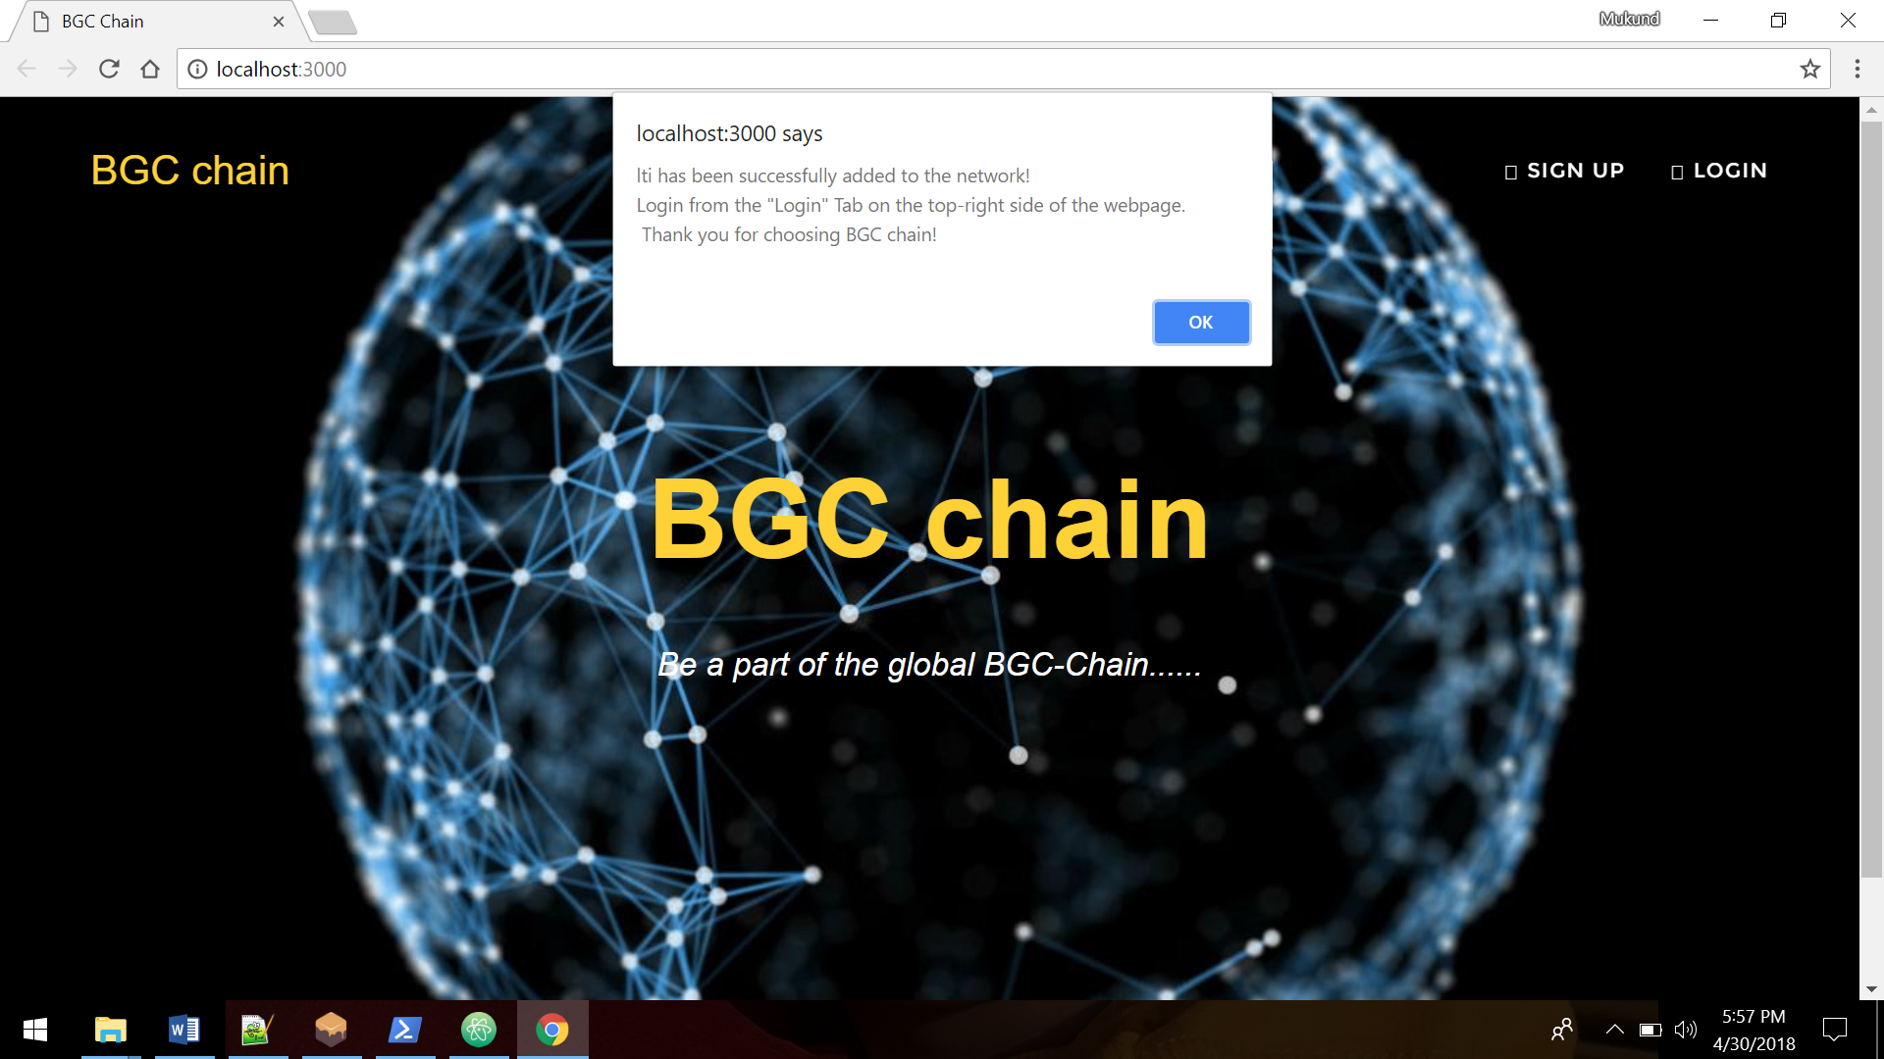

1. In case you don’t get above popup mean there is some issue in deployment.
2. Login with credentials

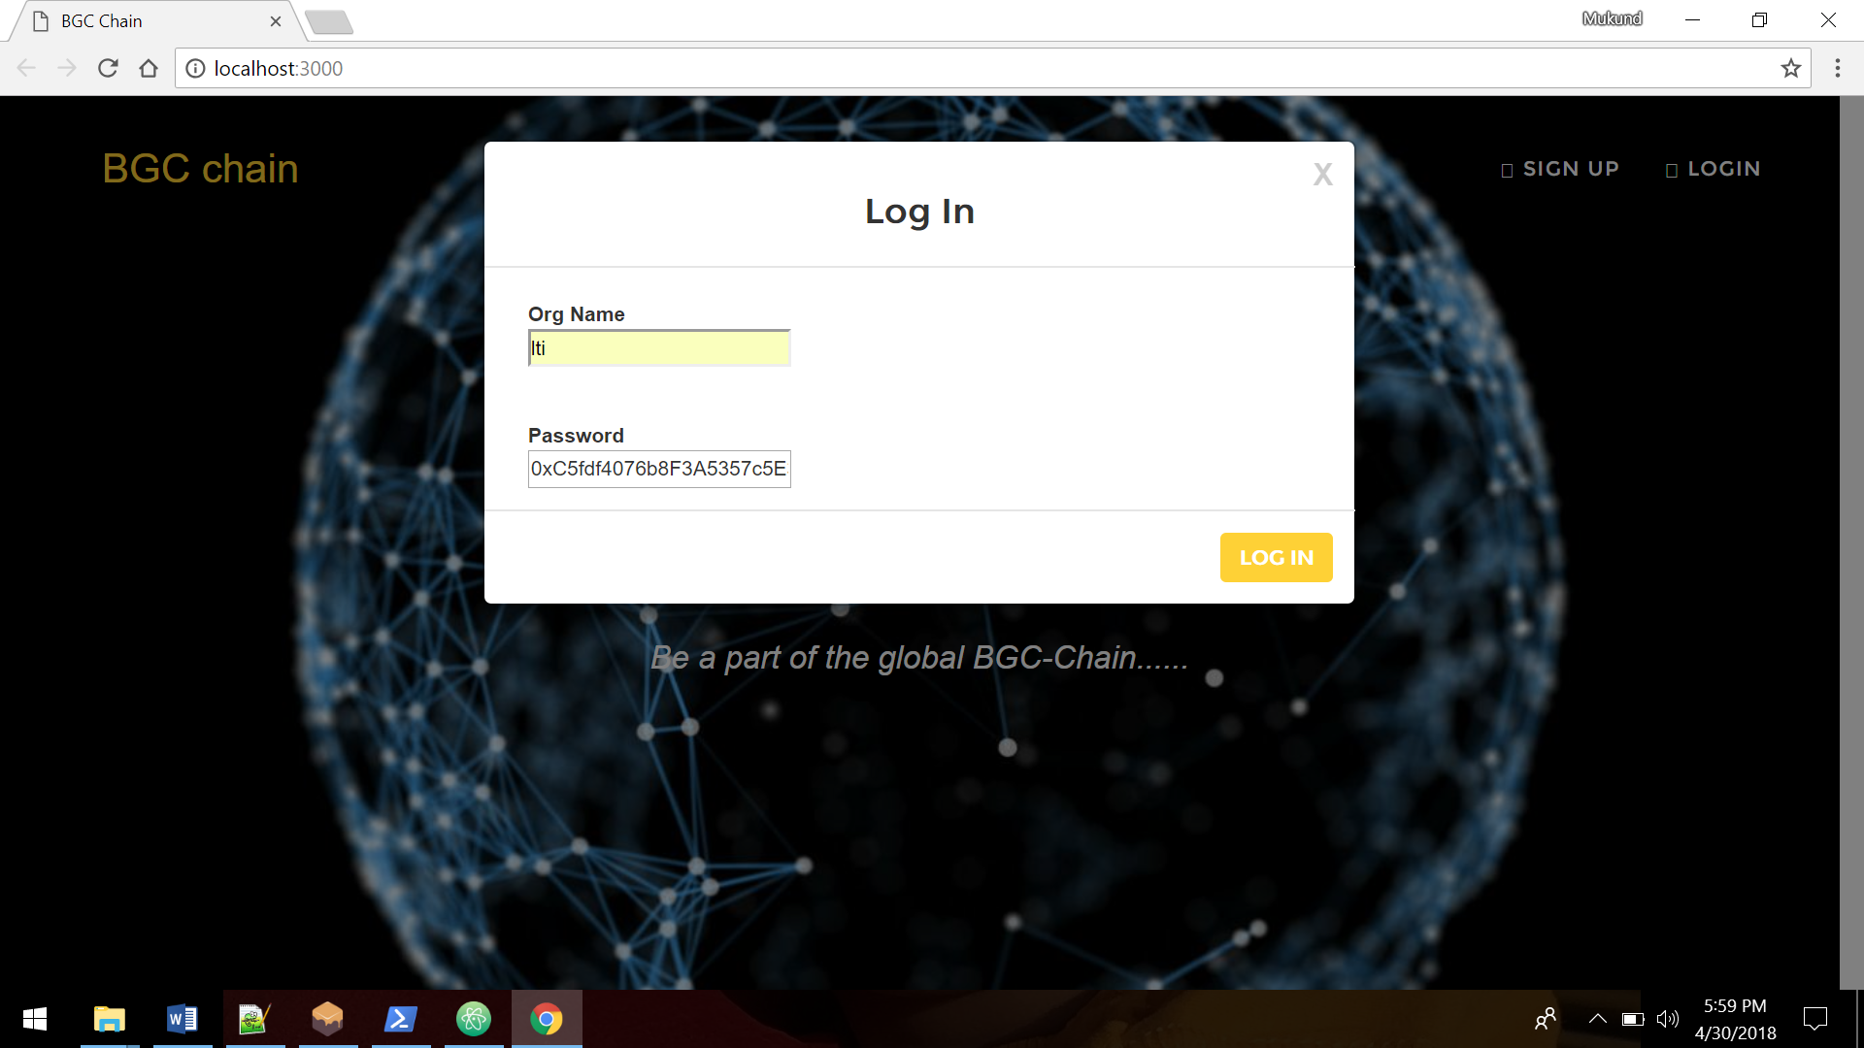

1. On Organization home page you will see org name other details

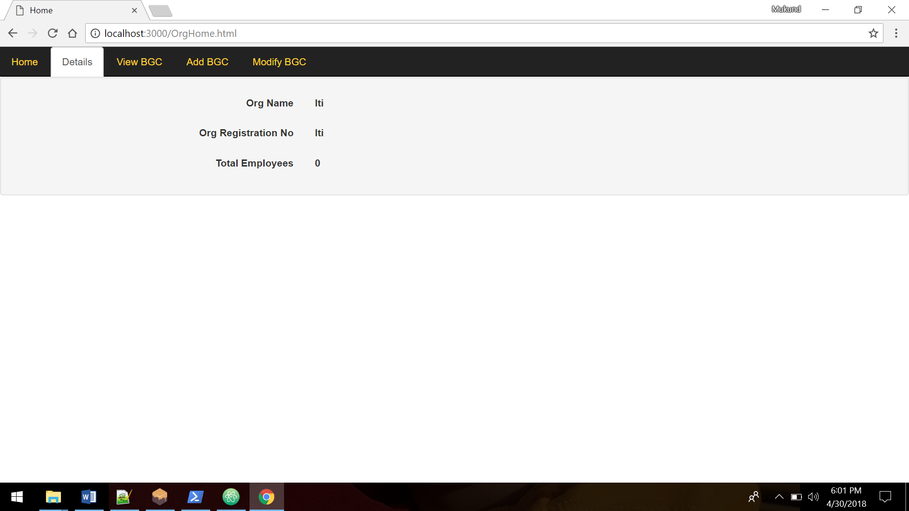

1. Click on Add BGC tab and provide employee details and submit.

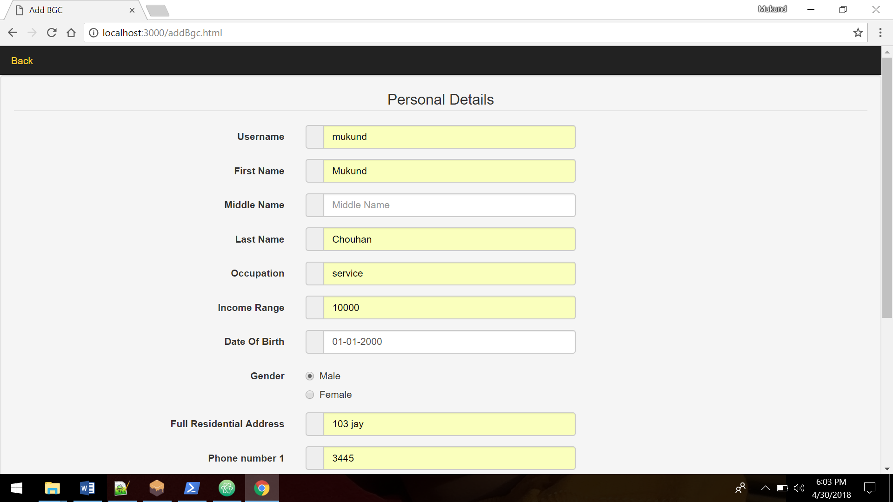

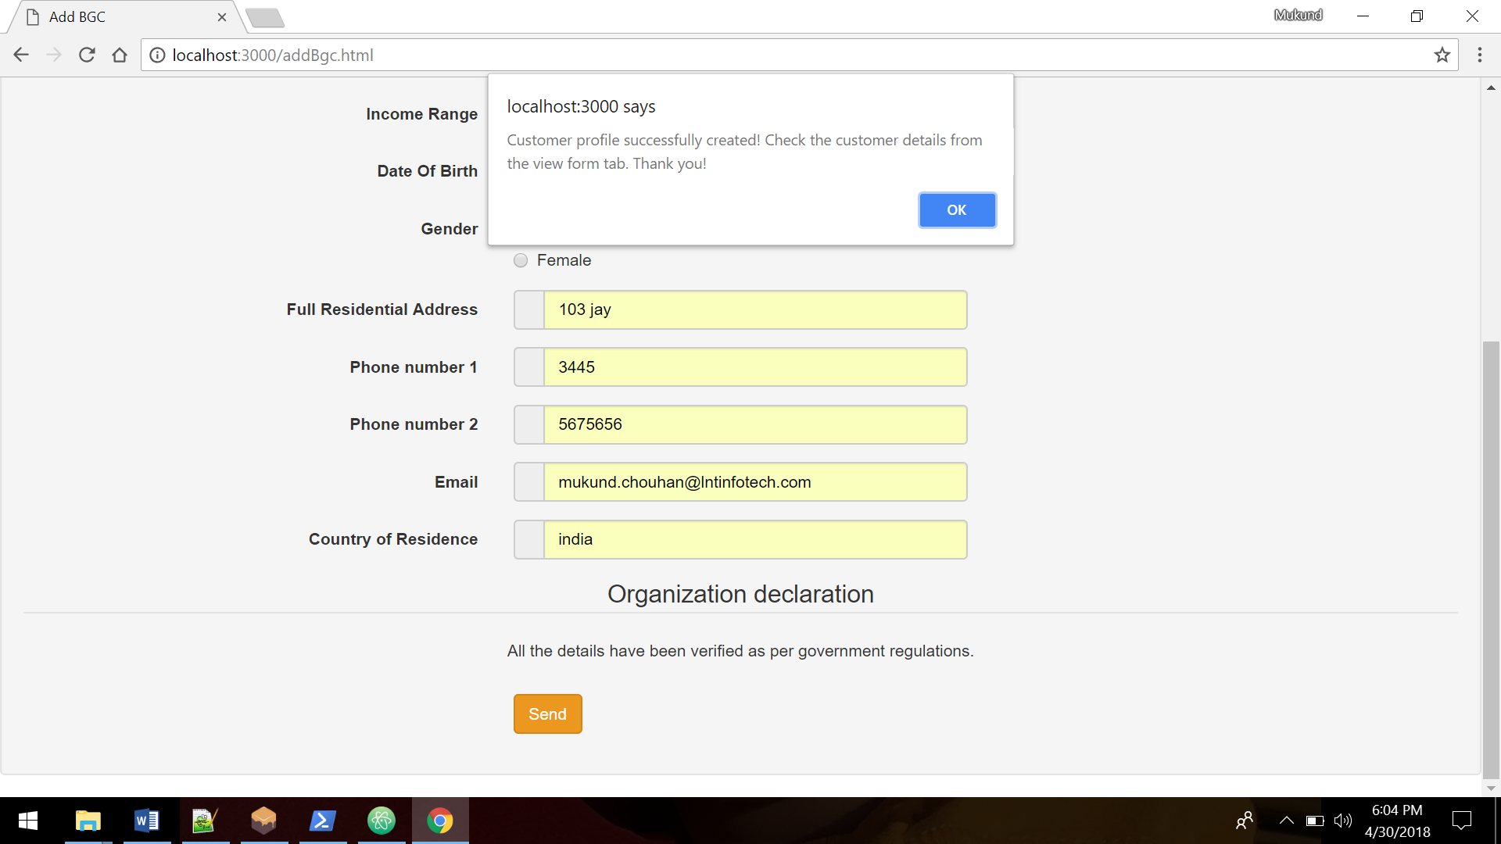

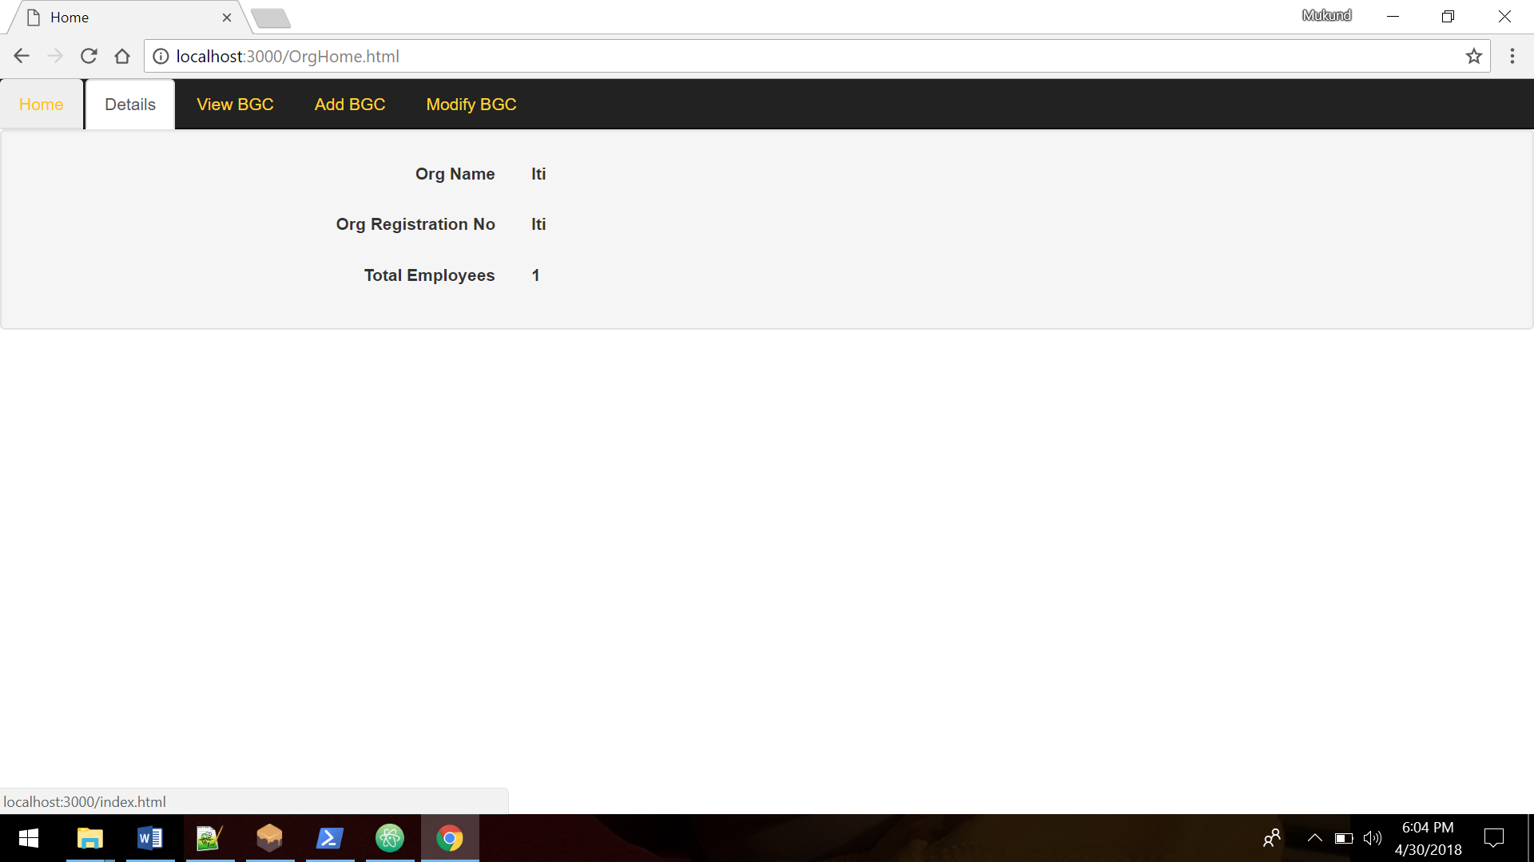

1. Now create employee profile using below link:

<http://localhost:3000/employeeLogin.html>

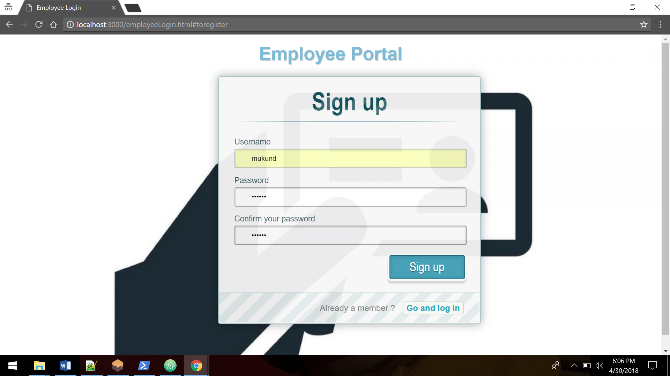

1. Login with created credentials

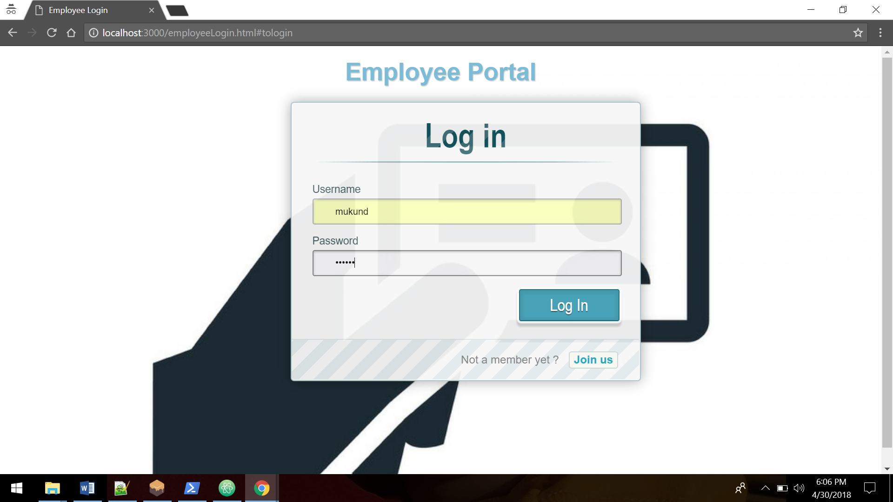

1. Employee will see his/her details on home screen

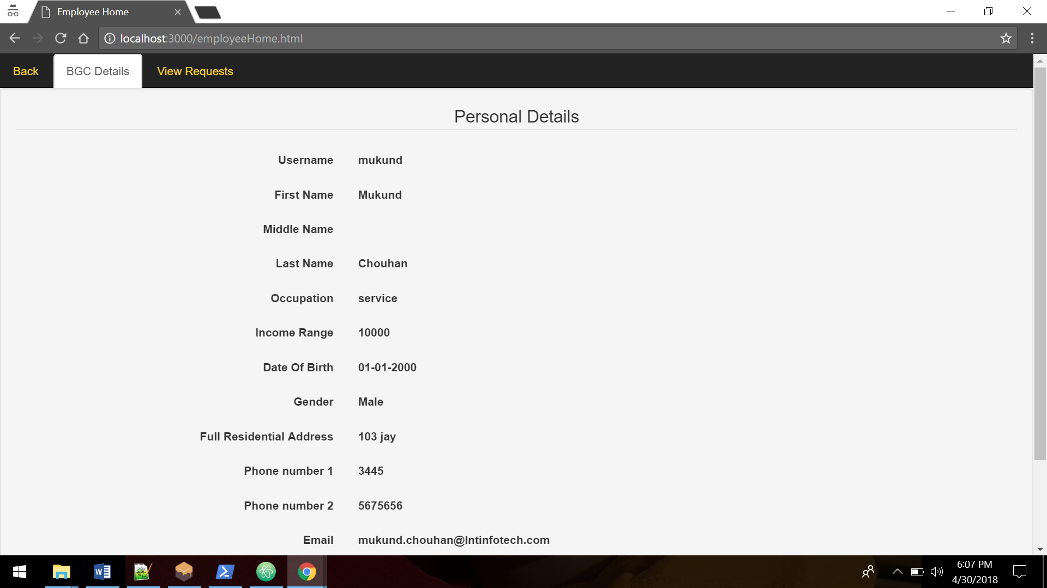

1. Add BGC view request using Organization portal

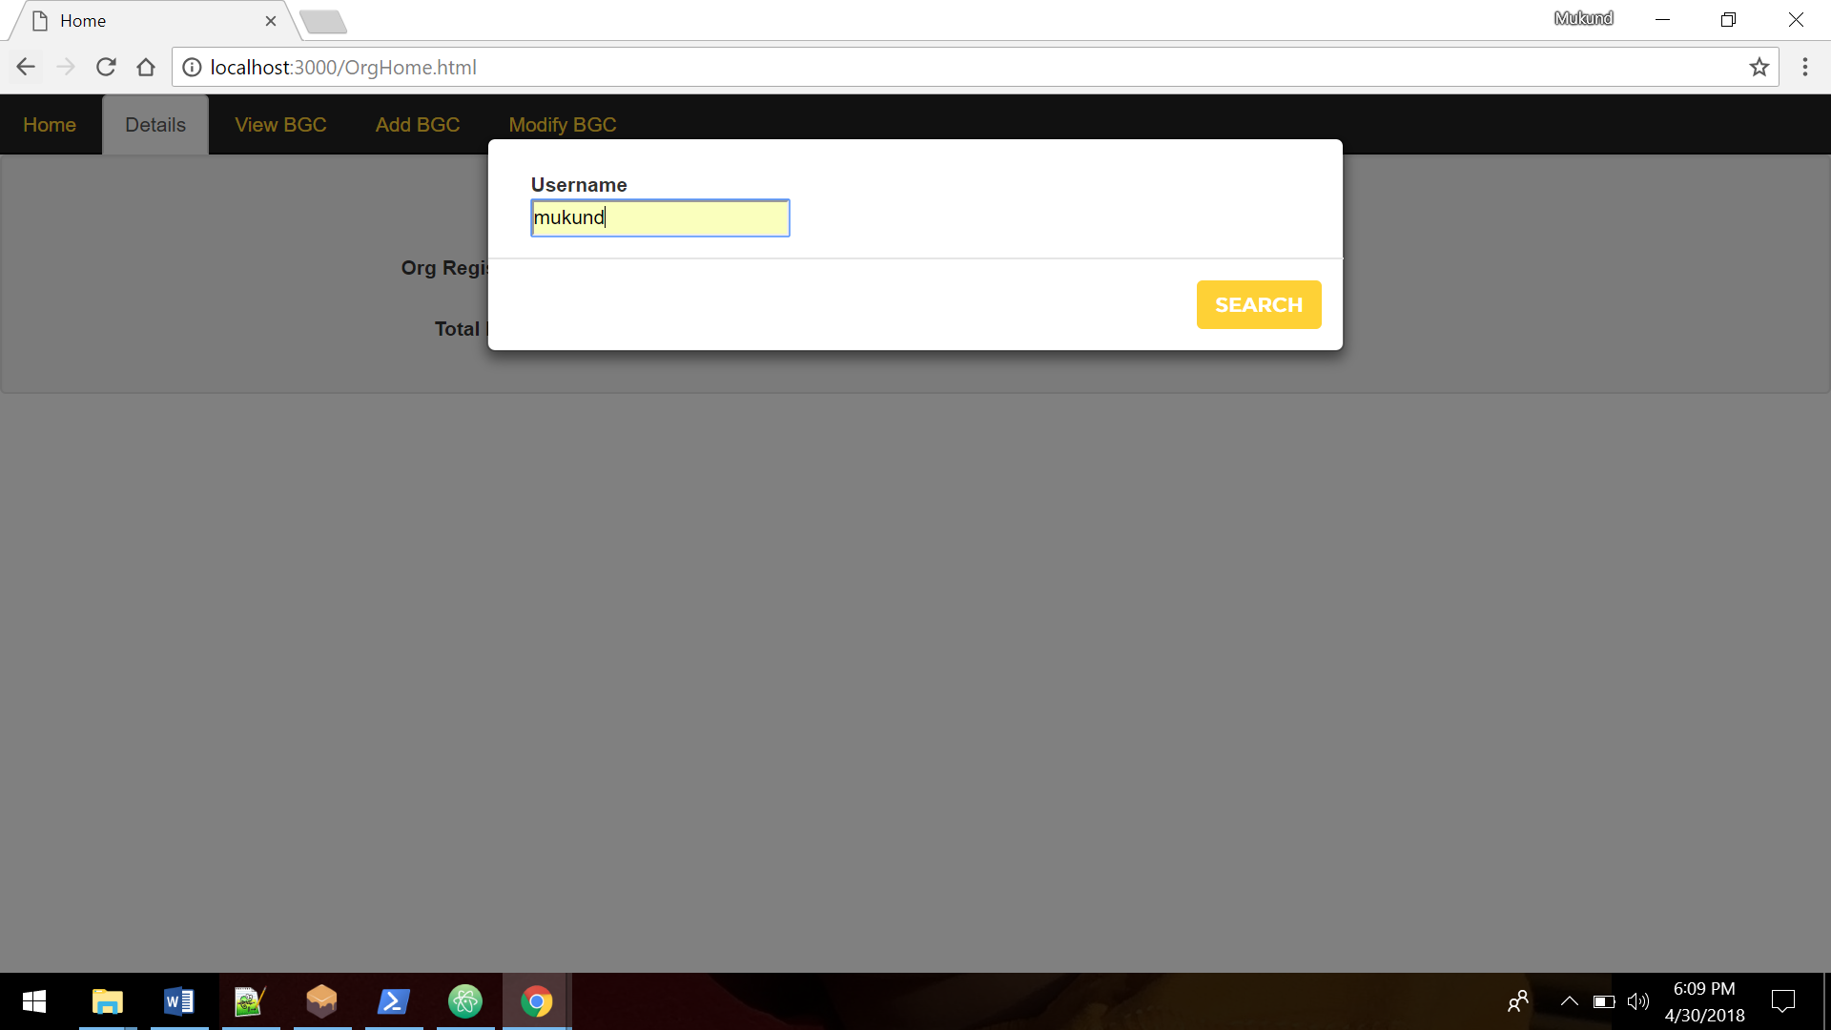

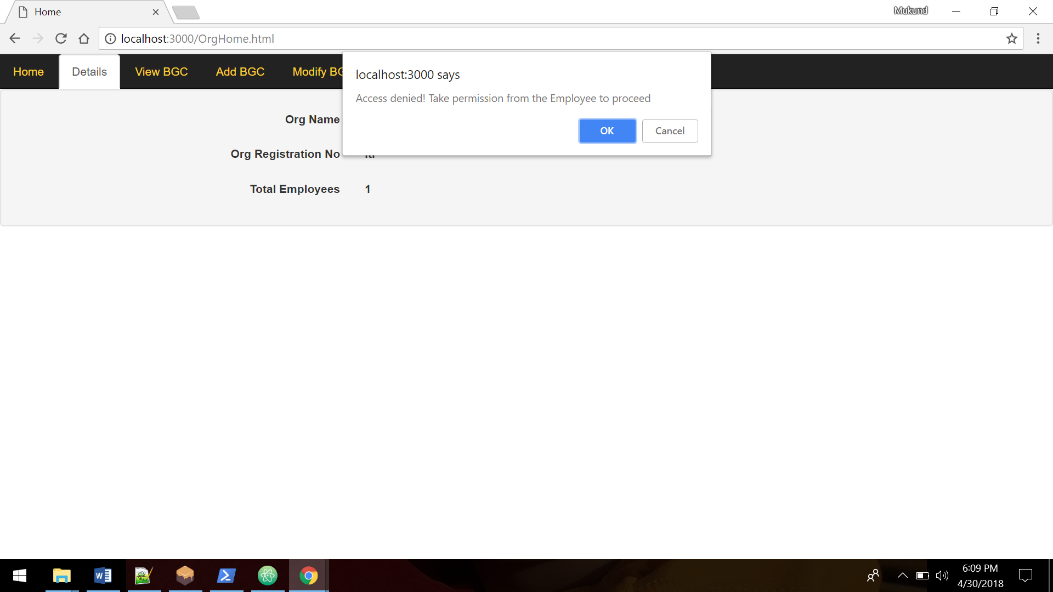

1. Navigate to View Request tab using Employee portal

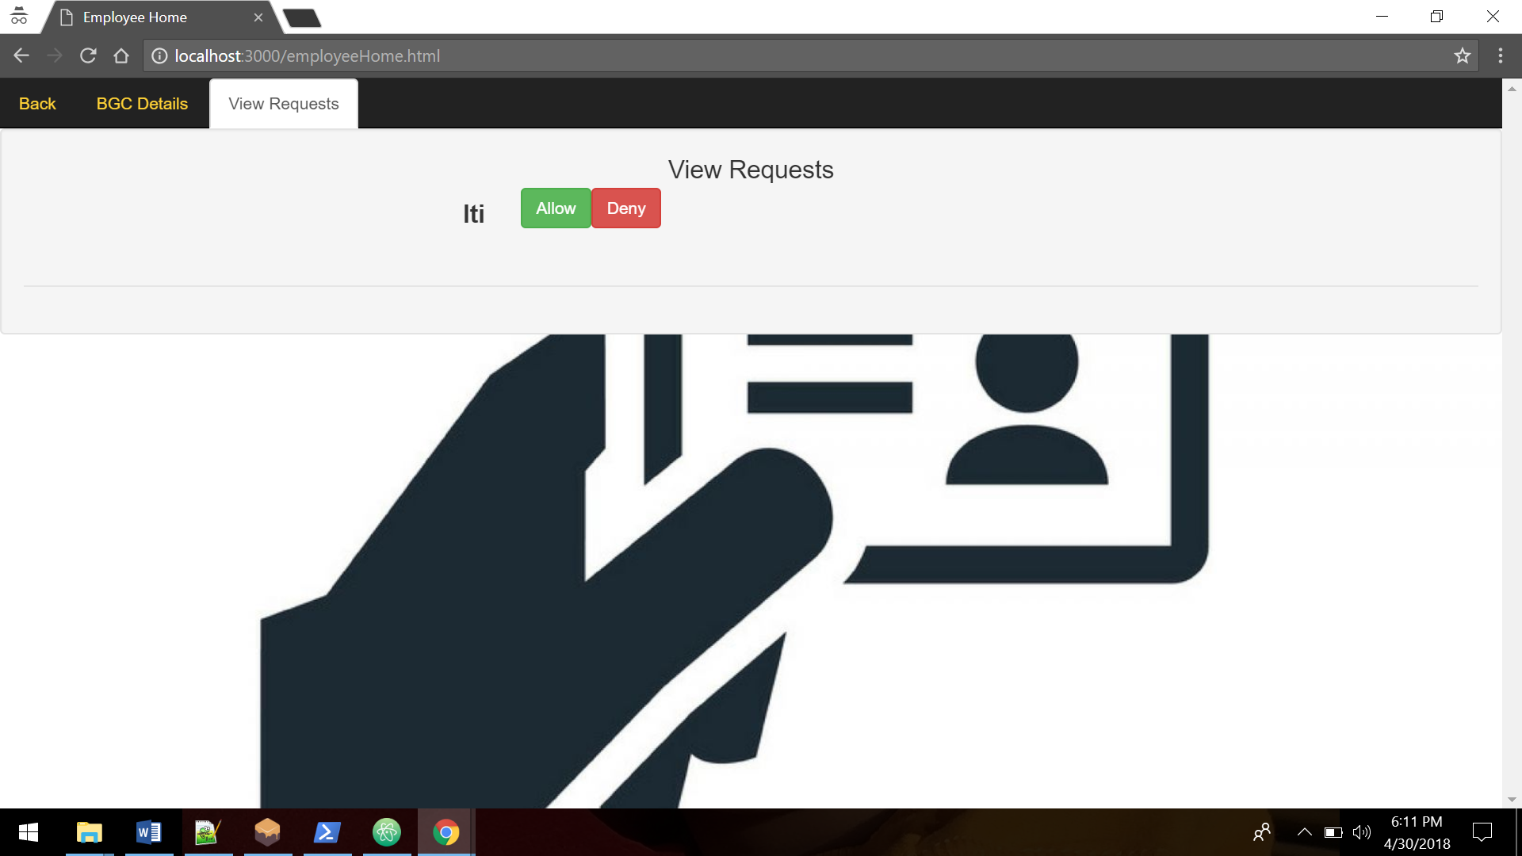

1. Allow View Request and navigate to Organization portal and click on View BGC tab. Now you will be able to see user details.

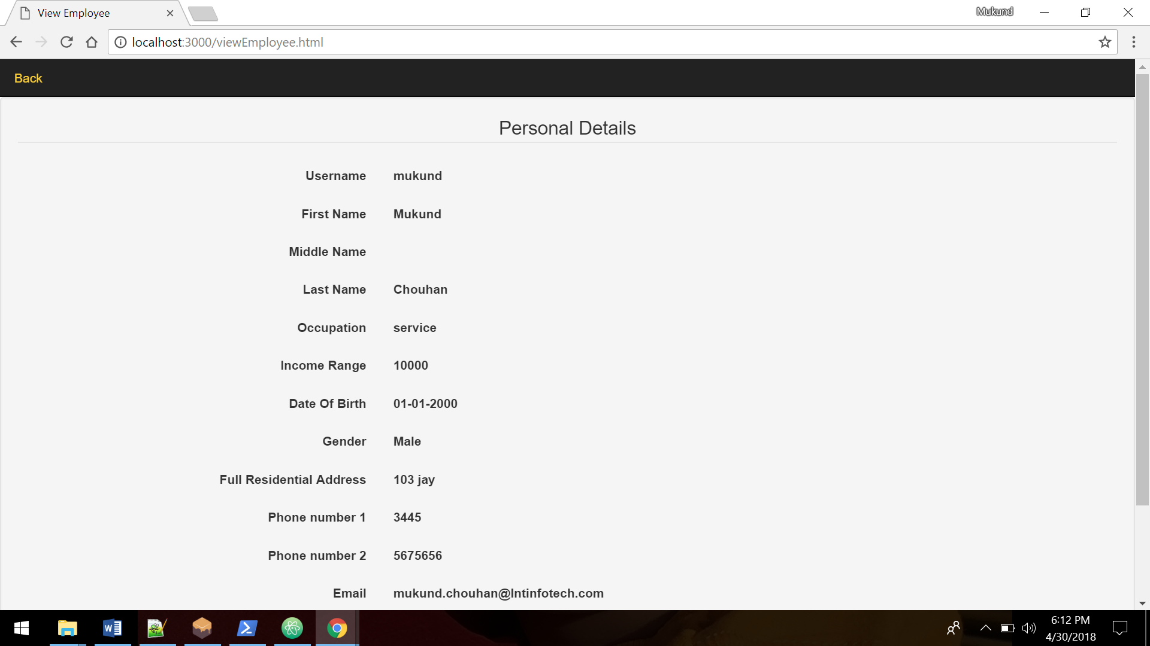

1. Now Click on Modify BGC tab and search for user

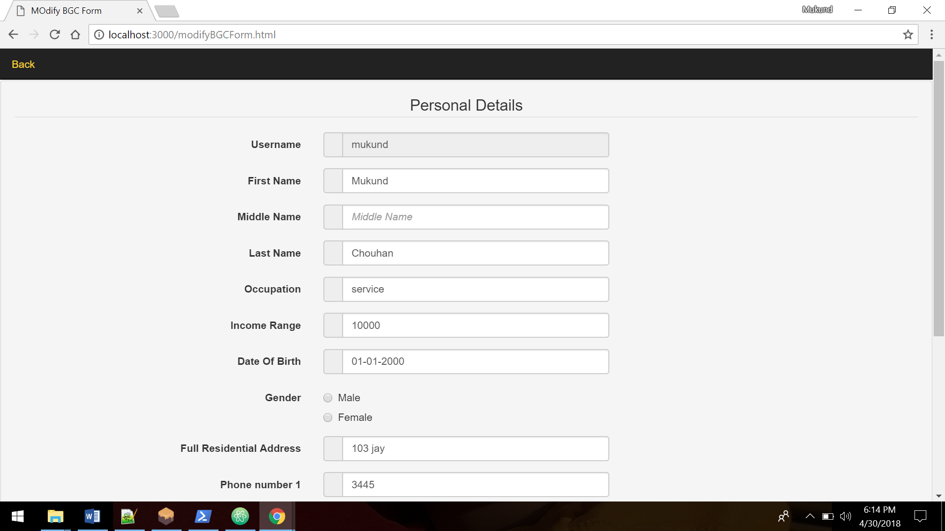

1. Update user details and submit

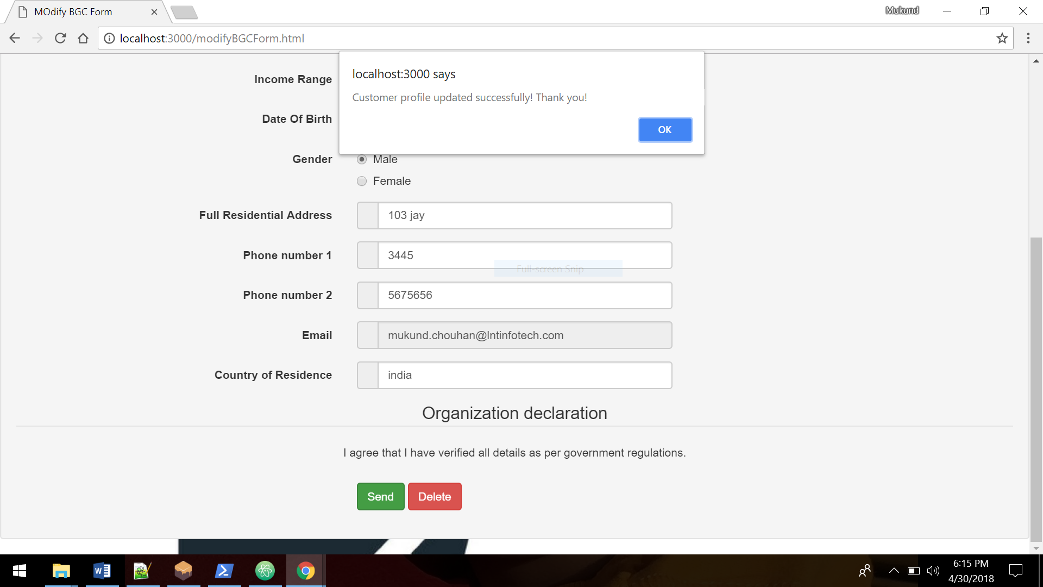

1. User will be able to see updated information.